# VISVESVARAYA TECHNOLOGICAL UNIVERSITY

Jnana Sangama, Belagavi, Karnataka - 590 018



### A DBMS Laboratory mini-Project Report

### on

**“****KALPATARU COURIER SERVICE”**

Submitted in partial fulfilment of the requirements for the award of Course completion in degree of

**Bachelor of Engineering**

## in

**Computer Science and Engineering**

Submitted By

**SHAMANTH BM 1KI21CS099**

Under the Guidance of

**Prof. Niranjan S.J**



Department of Computer Science and Engineering Kalpataru Institute of Technology

Tiptur - 572 201.

2023-2024

# VISVESVARAYA TECHNOLOGICAL UNIVERSITY

Jnana Sangama, Belagavi-590 018.

# KALPATARU INSTITUTE OF TECHNOLOGY

**Department of Computer Science and Engineering**

Tiptur-572 201.



# CERTIFICATE

This is to certify that the DBMS Laboratory mini- Project report entitled **“KALPATARU COURIER SERVICE”** is a bonafied work carried out by

**SHAMANTH BM 1KI21CS099**

in partial fulfilment for the completion of the laboratory work of the course subject **“DATA BASE MANAGEMENT SYSTEM”** with course code **“21CSL55”**, during the year 2023-2024. It is certified that all the corrections/suggestions indicated for internal assessment have been incorporated in the report deposited in the departmental library. The project report has been approved as it satisfies the academic requirements in respect of course activity work prescribed for the said degree.

|  |  |  |
| --- | --- | --- |
| **Guide**  **Prof. Niranjan S.J**  **Assistant Professor**  **Dept of CSE** |  | **HOD**  **Prof. Shashidhara M S**  **Associate Professor & HOD**  **Dept of CSE** |

# 

# KALPATARU INSTITUTE OF TECHNOLOGY

**Department of Computer Science and Engineering**

Tiptur-572 201.



# Acknowledgement

The satisfaction and great happiness that accompany the successful completion of **KALPATARU COURIER SERVICE** Project would be incomplete without mentioning about the people who made it possible. Here we make an honest attempt to express our deepest gratitude to all those who have been helpful and responsible for the successful completion of our project.

We would like to thank **Dr. GURUMURTHY G D,** **Principal**, Kalpataru Institute of Technology, Tiptur for his continuous support and encouragement throughout the course of this project.

We would like to thank **Prof. SHASHIDHARA M S, Head of Department**, Department of Computer Science and Engineering, Kalpataru Institute of Technology, Tiptur for his continuous support and encouragement throughout the course of this project.

We are immensely indebted to our internal guide Prof. Niranjan S and Dr Raviprakash M L, Department of Computer Science and Engineering, Kalpataru Institute of Technology, Tiptur for his support, technical assistance and constructive suggestions and guidance for successful completion of our project. We are very much thankful to him for the encouragement that has infused at most real into us to complete the project work.

We would like to thank all faculty members of Department of Computer Science and Engineering, KIT, Tiptur, our family members, and to our friends who are directly or indirectly responsible for our success.

Thanking you

**Shamanth BM**

**1KI21CS099**

# KALPATARU INSTITUTE OF TECHNOLOGY

**Department of Computer Science and Engineering**

Tiptur-572 201.



# Declaration

I, **SHAMANTH BM**, student of Fifth semester Bachelor of Engineering, Department of Computer Science and Engineering, Kalpataru Institute of Technology, Tiptur, would hereby declare that the Course Activity work entitled **“DATA BASE MANAGEMENT SYSTEM LABORATORY – 21CS55”** has been carried out by me at Kalpataru Institute of Technology and submitted in partial fulfillment of the course requirement for the award of degree of Bachelor of Engineering in Computer Science and Engineering of Visvesvaraya Technological University, Belagavi, during the academic year2023-2024. I further declare that the work embodied in this report has not been submitted to any other university or institution for the award of any other degree.

Place: Tiptur

Date :

Signature of student

Radhika Narayan Appinabail

Shalini L C

Prarthana Y J

Shamanth B M

**ABSTRACT**

This **Courier Management System** Project will have different modules. The login section will have login facility for the admin and for the user who will operate this system. While taking orders from its customers, it will take all the details of its customers who is placing the orders and all the details for the recipient such as its address, name, mobile number. Through the tracking id, customers or its recipient will able to track their products from any location using internet. It will provide status of the product after placing orders within 1 minute. The admin can manipulate the data through admin login page and add any new consignment if required. The profile section shows the data of the user and the ricing section of the project shows the price that will be charged for the consignment according to the weight categories.

Using the courier service person can easily send his/her parcel to other person in the particular destination within the time

**CONTENTS**

|  |  |  |
| --- | --- | --- |
| **CHAPTERS** |  | **PAGE NO** |
| Chapter 1 | Introduction | 1-2 |
| Chapter 2 | Requirements | 3-3 |
| Chapter 3 | Entity Relationship Diagram | 4-5 |
| Chapter 4 | Schema Diagram | 6-8 |
| Chapter 5 | Implementation | 9-18 |
| Chapter 6 | Snapshots | 19-24 |
|  | Conclusion | 25-25 |
|  | References | 25-25 |

**CHAPTER 1**

**Introduction**

This Courier Management System Project will have different modules. The login section will

have login facility for the admin and for the user who will operate this system. While taking orders from its customers, it will take all the details of its customers who is placing the orders and all the details for the recipient such as its address, name, mobile number. During billing process system will generate a tracking id for their products. Through this tracking id , customers or its recipient will able to track their products from any location using internet. It will provide status of the product after placing orders within 1 minute.

The courier service is one of the solutions of these problems. It is used to send some things to

any person in the world within time. The courier company has number of branches, which are

spread over the country or the world. So that when person wants to send things then he has to

contact at nearest courier service branch. The courier company creates the schedule & gives internal/external services. The courier service work as destination office or source office.

In modern age, as time increase, needs & requirements of the person are also increased. They want more facility & try to do their task quickly & within time. But they can not get all the things at nearest market or area, so they have to import the things from any place in the world.Within the country, the things can be imported through post service. But it consumes the time & sometimes problem of damage or missing occur. Where as in the international market, the one way is shipping. But it also requires more time.

**1.1 Motivation behind this project:**

To gain maximum business region, customer demands good service. So to make more profit and gain maximum business region, their administration must also have a system to tackle all

these problems on time. Its administration can take immediate orders and provide a receipt which will include all the details of the products along with appropriate price to their customers. Thus saving time and eliminating line making process.

**1.2 Features of Purposed System:**

These are the important features of the project Courier Management System:

• In computer system of the courier service computation of the rate is easily & quickly

done.

• Computer system of the courier service provide fast access.

• Using this computerized system, bill issued procedure becomes fast.

• In computer system the person has to fill the various forms & number of copies of the

forms can be easily generated at a time.

• In computer system, it is not necessary to create the Manifest but we can directly print it,

which saves our time.

• It contain better storage capacity.

• Accuracy in work.

• Easy & fast retrieval of information.

• Well designed reports.

• Decrease the load of the person involve in existing manual system.

• Access of any information individually.

• Work becomes very speedy.

• Easy to update information.

**CHAPTER 2**

**Software Environment**

**2.1 System Requirements:**

**2.1.1 Software Requirement:**

• Apache Server 2.0

• PHP Version 5.3 or above

• MySQL Version 5.5 or above

• Latest browser : Chorme, Firefox, Safari etc

• Operating System : Any (Linux, Windows, Mac etc)

**2.1.2 Hardware Requirements:**

• Processor Pentium IV or higher version.

• Ram 128 MB or above

• Hard Disk 150 MB or above

**CHAPTER 3**

**ENTITY RELATIONSHIP DIAGRAM**

An **Entity–relationship model (ER model)** describes the structure of a database with the help of a diagram, which is known as **Entity Relationship Diagram (ER Diagram)**. An ER model is a design or blueprint of a database that can later be implemented as a database. The main components of E-R model are: entity set and relationship set.

## What is an Entity Relationship Diagram (ER Diagram)?

An ER diagram shows the relationship among entity sets. An entity set is a group of similar entities and these entities can have attributes. In terms of DBMS, an entity is a table or attribute of a table in database, so by showing relationship among tables and their attributes, ER diagram shows the complete logical structure of a database.

The geometric shapes and their meaning in an E-R Diagram. We will discuss these terms in detail in the next section(Components of a ER Diagram) of this guide so don’t worry too much about these terms now, just go through them once.

**Rectangle**: Represents Entity sets.  
**Ellipses**: Attributes  
**Diamonds**: Relationship Set  
**Lines**: They link attributes to Entity Sets and Entity sets to Relationship Set  
**Double Ellipses:** Multivalued Attributes  
**Dashed Ellipses**: Derived Attributes  
**Double Rectangles**: Weak Entity Sets  
**Double Lines**: Total participation of an entity in a relationship set

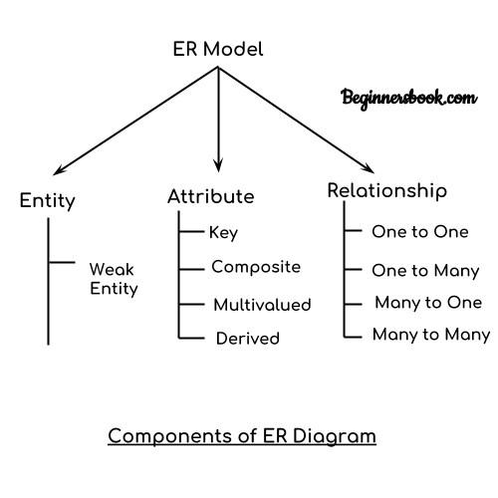

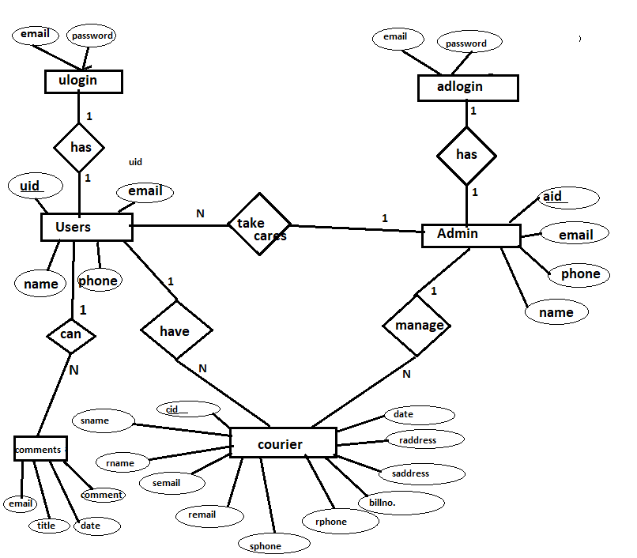

Fig.3.1 ER diagram of Kalpataru Courier Service.

**CHAPTER 4**

**ENTITY RELATIONSHIP SCHEMA DIAGRAM**

A database schema is the skeleton structure that represents the logical view of the entire database. It defines how the data is organized and how the relations among them are associated. It formulates all the constraints that are to be applied on the data.

A database schema defines its entities and the relationship among them. It contains a descriptive detail of the database, which can be depicted by means of schema diagrams.

An Entity-Relationship Model (ERM) is an abstract and conceptual representation of data. Entity-relationship modeling is a database modeling method, used to produce a type of conceptual schema or semantic data model of a system, often a relational database, and its requirements in a top-down fashion.

In order to create an ER schema you must know three main concepts: entity, attribute and relationship.

**4.1 Entity**

Entity is the central concept of the Entity-Relationship model. An entity represents a description of the common features of set of objects of the real world. Examples of entities are Person, Car, Artist, and Album.

### 4.2 Attribute

An Attribute represents the properties of real world objects that are relevant for the application purposes. Attributes are associated with the concept of Entity, with the meaning that all the instances of the entity are characterized by the same set of attributes. In other words, the entity is a descriptor of the common properties of a set of objects, and such properties are expressed as attributes.

### 4.3 Relationship

A Relationship represents semantic connections between entities, like the association between an artist and his/her album, or between an artist and his/her reviews.

The possible values are one and many. Based on their maximum cardinality constraints, relationships are called

1."one-to-one", if both relationships roles have maximum cardinality 1,

2."one-to-many", if one relationship role has maximum cardinality 1 and the other role has maximum cardinality N,

3."many-to-many", if both relationships roles have maximum cardinality N

**4.4 E-R Schema Normalization**

E-R includes some concept that are not minimal but which can be specified through the usage of the three main concepts of the ER Schema. These concepts are:

* Multi value attributes.

Attributes of an object that can take a set of values represented by an entity and a relationship

* Composed attributes.

Attributes with an internal structure (i.e, an address can include different fields), represented by using an entity and a relationship

* N-array relationships.

Represented by a central entity and two reports

* Relationships with attributes.

Relationships involving N entities

**4.5 ER SCHEMA DIAGRAM FOR COURIER MANAGEMENT SYSTEM**

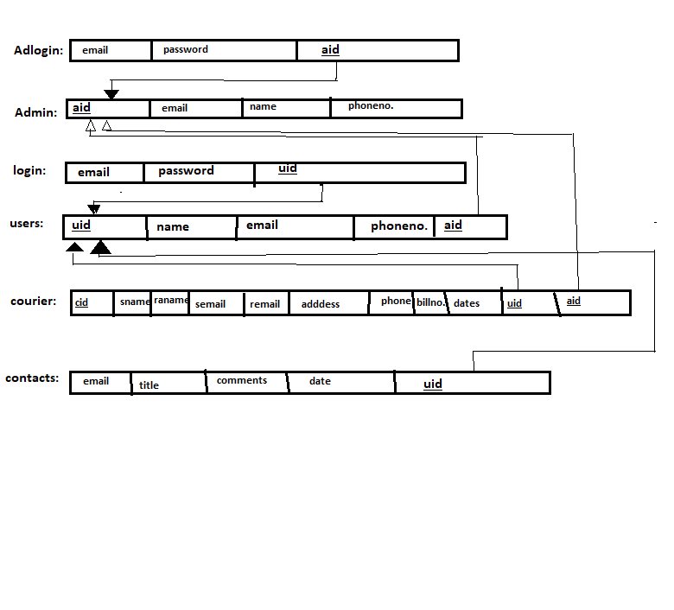

Fig. 4.2. ER Diagram of Courier management System

**CHAPTER 5**

**IMPLEMENTATION**

**5.1 SAMPLE FRONTEND CODE**

**5.1.1. INDEX.PHP**

<?php

require_once "dbconnection.php";

require_once "session.php";

if ($_SERVER["REQUEST_METHOD"] == "POST" && isset($_POST['submit'])) {

$email = $_POST['email'];

$password = $_POST['password'];

$qry = "SELECT * FROM `login` WHERE `email`='$email' AND `password`='$password'";

$run = mysqli_query($dbcon, $qry);

$row = mysqli_num_rows($run);

if ($row < 1) {

?>

<script>

alert("Opps! plz Enter Your Username and Pswd again..");

window.open('index.php', '_self');

</script> <?php

} else {

$data = mysqli_fetch_assoc($run);

$id = $data['u_id']; //fetch id value of user

$email = $data['email'];

$_SESSION['uid'] = $id; //now we can use it until session destroy

$_SESSION['emm'] = $email;

?>

<script>

alert("स्वागत हैं आपका 🙏");

window.open('home/home.php', '_self');

// changes made here

</script> <?php

}

}

<!DOCTYPE html>

<html lang="en">

<head>

<meta charset="UTF-8">

<meta name="viewport" content="width=device-width, initial-scale=1.0">

<title>Login</title>

<link rel="stylesheet" href="https://stackpath.bootstrapcdn.com/bootstrap/4.4.1/css/bootstrap.min.css">

<style>

body {

background-image: url('images/10.jpg');

background-repeat: no-repeat;

background-size: cover;

}

</style>

</head>

<body>

<h1 align='center' style="margin: 15px; color:seagreen;font-weight: bold;font-family:'Times New Roman', Times, serif">TYPHOON COURIER SERVICE</h1>

<hr />

<P align='center' style="font-weight: bold;color:orange;font-family:'Times New Roman', Times, serif">The Fastest Courier Service Ever</P>

<div>

<h5><a href="admin/adminlogin.php" style="float: right; margin-right:40px; color:blue; margin-top:0px">AdminLogin</a></h5>

</div>

<div class="container" style="margin-top: 60px; width:50%;">

<div class="row">

<div class="col-md-12">

<h2 style="color: #273c75;">Login</h2>

<p style="color:#e84118;">Please Fill Your ⮯⮯</p>

<!-- <?php echo $error; ?> -->

<form action="" method="post">

<div class="form-group">

<label>Email Address</label>

<input type="email" name="email" class="form-control" placeholder="Enter username/emailId" required />

</div>

<div class="form-group">

<label>Password</label>

<input type="password" name="password" class="form-control" placeholder="Enter your password" required>

</div>

<div class="form-group">

<input type="submit" name="submit" class="btn btn-primary" value="SignIn" />

<button onclick="window.location.href='resetpswd.php'" class="btn btn-danger" style="cursor:pointer">Reset Password</button>

</div>

<p style="color: #e84118;">Don't have an account?⮞➤ <a href="register.php">Register here</a>.</p>

</form>

</div>

</div>

</div>

</body></html>

**2.1.2. BACKEND CODE**

-- phpMyAdmin SQL Dump

-- version 5.0.3

-- https://www.phpmyadmin.net/

--

-- Host: 127.0.0.1

-- Generation Time: Dec 31, 2020 at 11:41 AM

-- Server version: 10.4.14-MariaDB

-- PHP Version: 7.4.11

SET SQL_MODE = "NO_AUTO_VALUE_ON_ZERO";

START TRANSACTION;

SET time_zone = "+00:00";

/*!40101 SET @OLD_CHARACTER_SET_CLIENT=@@CHARACTER_SET_CLIENT */;

/*!40101 SET @OLD_CHARACTER_SET_RESULTS=@@CHARACTER_SET_RESULTS */;

/*!40101 SET @OLD_COLLATION_CONNECTION=@@COLLATION_CONNECTION */;

/*!40101 SET NAMES utf8mb4 */;

--

-- Database: `courierdb`

--

-- --------------------------------------------------------

--

-- Table structure for table `adlogin`

--

CREATE TABLE `adlogin` (

`email` varchar(50) DEFAULT NULL,

`password` varchar(50) DEFAULT NULL,

`a_id` int(11) DEFAULT NULL

) ENGINE=InnoDB DEFAULT CHARSET=utf8mb4;

--

-- Dumping data for table `adlogin`

--

INSERT INTO `adlogin` (`email`, `password`, `a_id`) VALUES

('premkumar1215225@gmail.com', '1215225', 1),

('himanshu.18is027@cambridge.edu.in', '1cd18is027', 2);

-- --------------------------------------------------------

-- Table structure for table `admin`

--

CREATE TABLE `admin` (

`a_id` int(11) NOT NULL,

`email` varchar(50) NOT NULL,

`name` varchar(50) DEFAULT NULL,

`pnumber` int(14) DEFAULT NULL

) ENGINE=InnoDB DEFAULT CHARSET=utf8mb4;

--

-- Dumping data for table `admin`

INSERT INTO `admin` (`a_id`, `email`, `name`, `pnumber`) VALUES

(1, 'premkumar1215225@gmail.com', 'Prem', 63627862),

(2, 'himanshu.18is027@cambridge.edu.in', 'Himanshu Soni', 123456789);

-- --------------------------------------------------------

--

-- Table structure for table `contacts`

--

CREATE TABLE `contacts` (

`id` int(11) NOT NULL,

`email` varchar(50) NOT NULL,

`subject` varchar(30) NOT NULL,

`msg` varchar(300) NOT NULL

) ENGINE=InnoDB DEFAULT CHARSET=utf8mb4;

--

-- Dumping data for table `contacts`

--

CREATE TABLE `contacts` (

`id` int(11) NOT NULL,

`email` varchar(50) NOT NULL,

`subject` varchar(30) NOT NULL,

`msg` varchar(300) NOT NULL

) ENGINE=InnoDB DEFAULT CHARSET=utf8mb4;

--

-- Dumping data for table `contacts`

--

INSERT INTO `contacts` (`id`, `email`, `subject`, `msg`) VALUES

(1, 'love@gmail.com', 'delay', 'I have courier 2 weeks ago but its not delivered yet..'),

(2, 'labh.18is033@cambridge.edu.in', 'Delay', 'gjndfjkgnhdfjkgn');

-- --------------------------------------------------------

--

-- Table structure for table `courier`

--

CREATE TABLE `courier` (

`c_id` int(11) NOT NULL,

`u_id` int(11) DEFAULT NULL,

`semail` varchar(50) DEFAULT NULL,

`remail` varchar(50) DEFAULT NULL,

`sname` varchar(50) DEFAULT NULL,

`rname` varchar(50) DEFAULT NULL,

`sphone` varchar(20) DEFAULT NULL,

`rphone` varchar(20) DEFAULT NULL,

`saddress` varchar(50) DEFAULT NULL,

`raddress` varchar(50) DEFAULT NULL,

`weight` int(11) DEFAULT NULL,

`billno` int(11) NOT NULL,

`image` text DEFAULT NULL,

`date` date NOT NULL

) ENGINE=InnoDB DEFAULT CHARSET=utf8mb4;

--

-- Dumping data for table `courier`

--

INSERT INTO `courier` (`c_id`, `u_id`, `semail`, `remail`, `sname`, `rname`, `sphone`, `rphone`, `saddress`, `raddress`, `weight`, `billno`, `image`, `date`) VALUES

(7, 4, 'love@gmail.com', 'himanshu@gmail.com', 'love', 'himanshu', '06362786223', '6526652', 'KR puram,Bangalore,Karnataka', 'Boys hostel of Cambridge institute of technology,j', 2, 22, 'cddd.jpeg', '2020-12-06'),

(8, 4, 'love@gmail.com', 'gyanshu@gmail.com', 'love', 'gyanshu', '06362786223', '06362786223', 'KR puram,Bangalore,Karnataka', 'Boys hostel of Cambridge institute of technology,j', 2, 3263, 'fc.png', '2020-12-06');

-- -------------------------------------------------------

--

-- Table structure for table `login`

--

CREATE TABLE `login` (

`email` varchar(50) DEFAULT NULL,

`password` varchar(50) DEFAULT NULL,

`u_id` int(11) DEFAULT NULL

) ENGINE=InnoDB DEFAULT CHARSET=utf8mb4;

--

-- Dumping data for table `login`

--

INSERT INTO `login` (`email`, `password`, `u_id`) VALUES

('premkumar1215225@gmail.com', '12345', 1),

('love@gmail.com', '12345', 4);

-- --------------------------------------------------------

--

-- Table structure for table `users`

--

CREATE TABLE `users` (

`u_id` int(11) NOT NULL,

`email` varchar(50) NOT NULL,

`name` varchar(50) DEFAULT NULL,

`pnumber` int(14) DEFAULT NULL

) ENGINE=InnoDB DEFAULT CHARSET=utf8mb4;

--

-- Dumping data for table `users`

--

INSERT INTO `users` (`u_id`, `email`, `name`, `pnumber`) VALUES

(1, 'premkumar1215225@gmail.com', 'prem', 56665),

(4, 'love@gmail.com', 'LOVE RAJ', 2147483647);

--

-- Indexes for dumped tables

--

-- Indexes for table `adlogin`

--

ALTER TABLE `adlogin`

ADD KEY `a_id` (`a_id`);

--

-- Indexes for table `admin`

--

ALTER TABLE `admin`

ADD PRIMARY KEY (`a_id`),

ADD UNIQUE KEY `email` (`email`);

--

-- Indexes for table `contacts`

--

ALTER TABLE `contacts`

ADD PRIMARY KEY (`id`);

--

-- Indexes for table `courier`

--

ALTER TABLE `courier`

ALTER TABLE `login`

ADD KEY `u_id` (`u_id`);

--

-- Indexes for table `users`

--

ALTER TABLE `users`

ADD PRIMARY KEY (`u_id`),

ADD UNIQUE KEY `email` (`email`);

--

-- AUTO_INCREMENT for dumped tables

--

-- AUTO_INCREMENT for table `admin`

--

ALTER TABLE `admin`

MODIFY `a_id` int(11) NOT NULL AUTO_INCREMENT, AUTO_INCREMENT=3;

--

-- AUTO_INCREMENT for table `contacts`

--

ALTER TABLE `contacts`

MODIFY `id` int(11) NOT NULL AUTO_INCREMENT, AUTO_INCREMENT=3;

--

-- AUTO_INCREMENT for table `courier`

--

ALTER TABLE `courier`

MODIFY `c_id` int(11) NOT NULL AUTO_INCREMENT, AUTO_INCREMENT=10;

--

-- AUTO_INCREMENT for table `users`

--

ALTER TABLE `users`

MODIFY `u_id` int(11) NOT NULL AUTO_INCREMENT, AUTO_INCREMENT=5;

-- Constraints for dumped tables

--

-- Constraints for table `adlogin`

ALTER TABLE `adlogin`

ADD CONSTRAINT `adlogin_ibfk_1` FOREIGN KEY (`a_id`) REFERENCES `admin` (`a_id`);

--

-- Constraints for table `courier`

--

ALTER TABLE `courier`

ADD CONSTRAINT `courier_ibfk_1` FOREIGN KEY (`u_id`) REFERENCES `users` (`u_id`) ON DELETE CASCADE;

--

-- Constraints for table `login`

--

ALTER TABLE `login`

ADD CONSTRAINT `login_ibfk_1` FOREIGN KEY (`u_id`) REFERENCES `users` (`u_id`) ON DELETE CASCADE;

CMMIT;

/*!40101 SET CHARACTER_SET_CLIENT=@OLD_CHARACTER_SET_CLIENT */;

/*!40101 SET CHARACTER_SET_RESULTS=@OLD_CHARACTER_SET_RESULTS */;

/*!40101 SET COLLATION_CONNECTION=@OLD_COLLATION_CONNECTION */;

**END OF IMPLEMENTATION CODE OF THE PROJECT**

**CHAPTER 6**

**SNAPSHOTS**

**6.1.USER LOGIN PAGE**

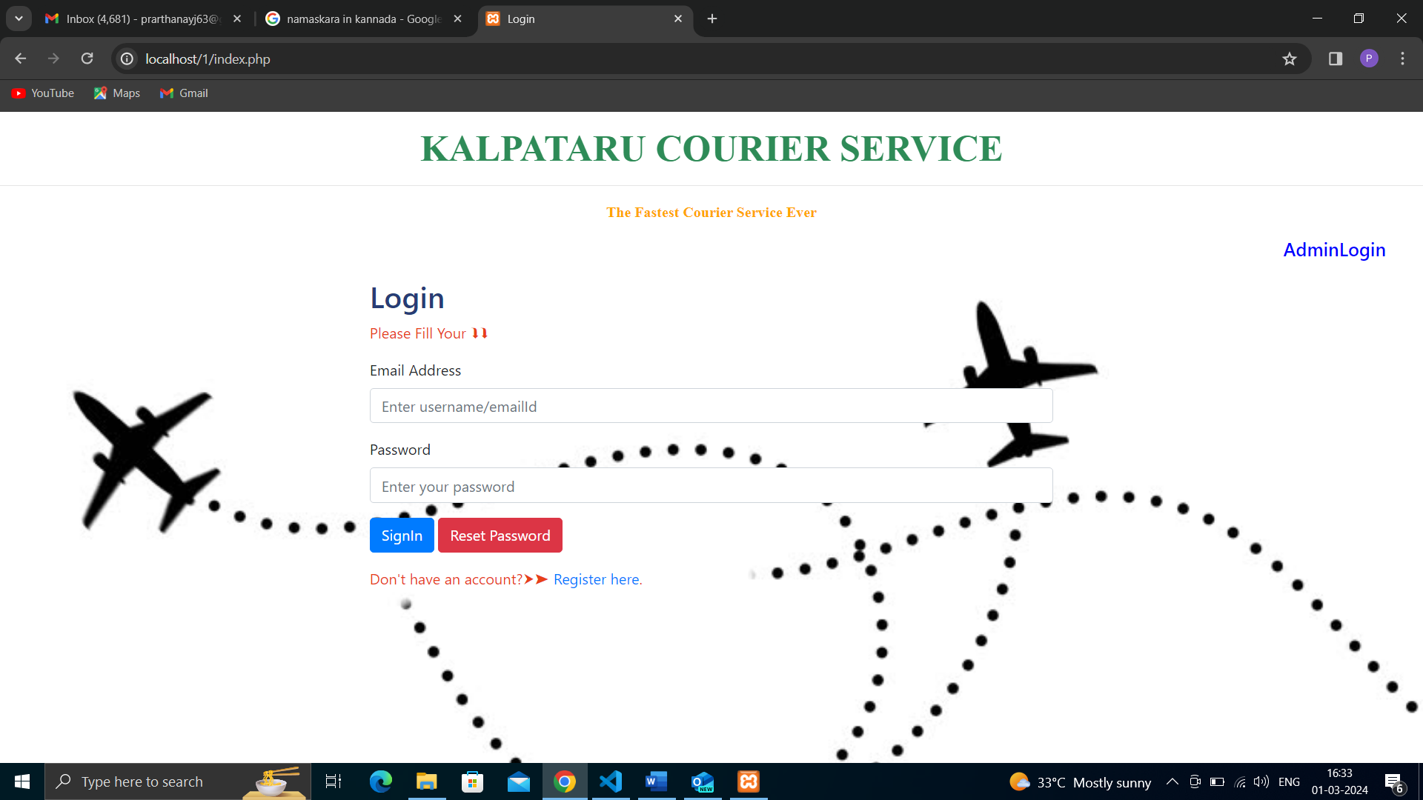

Fig 6.1:User Login Page

**6.2 HOME PAGE**

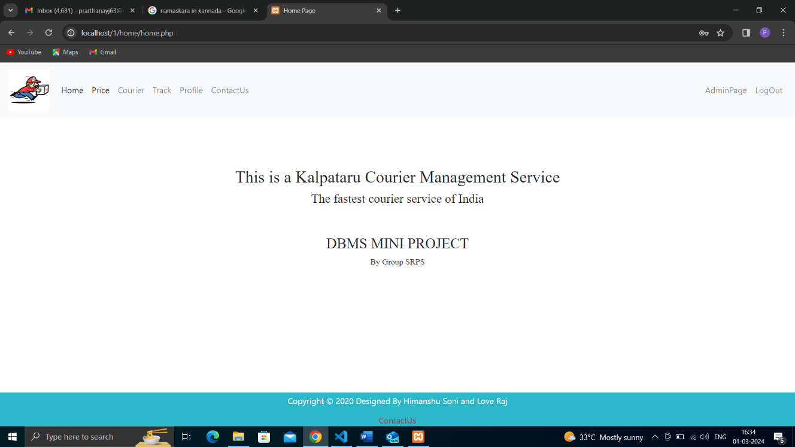

Fig 6.2:Home Page

**6.3 PRICING OF COURIER**

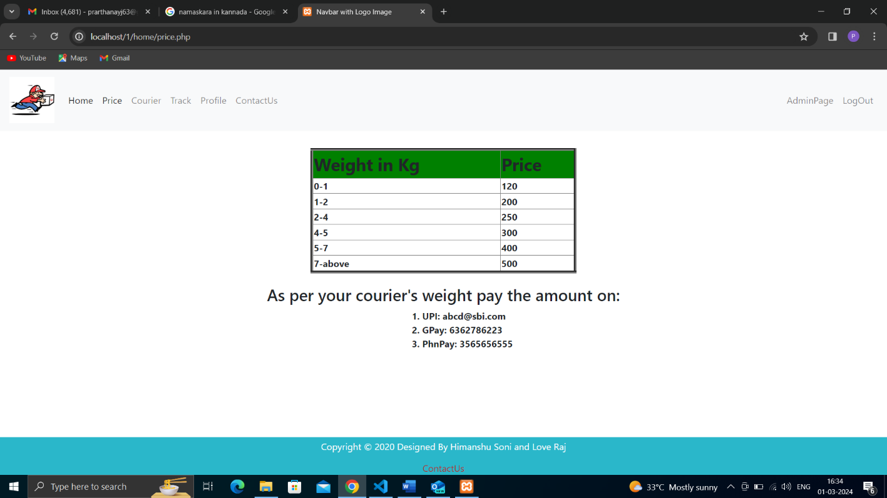

Fig 6.3: Pricing of courier

**6.4 COURIER SENDING PAGE**

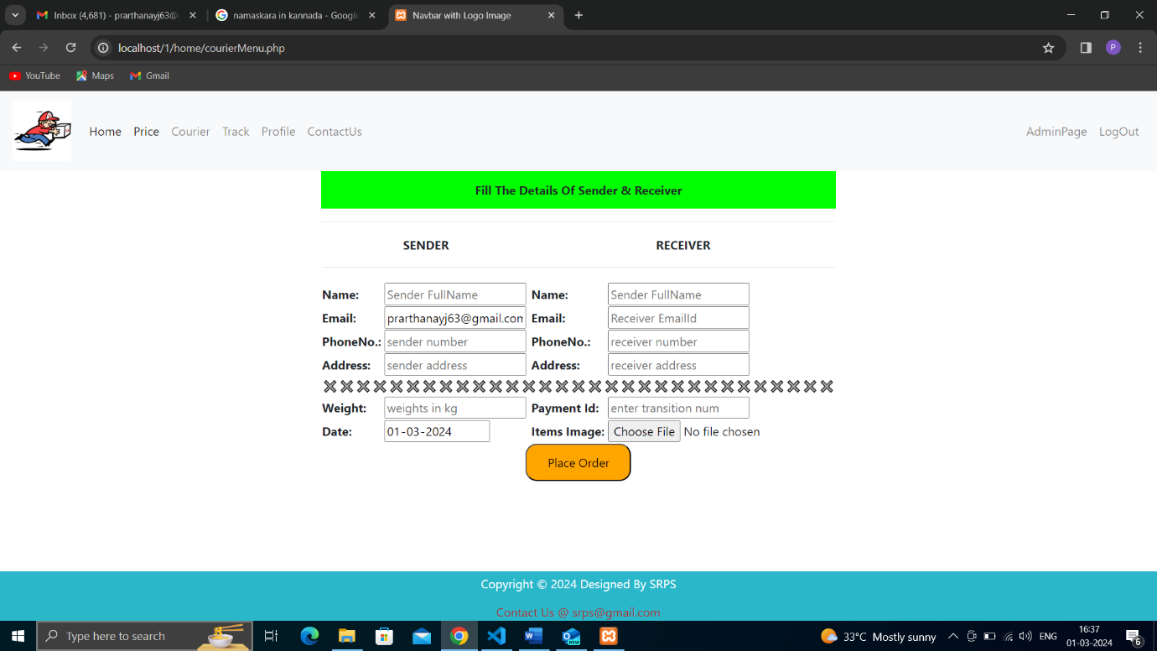

Fig 6.5: Courier sending page

**6.5 TRACK CONSIGNMENT PAGE**

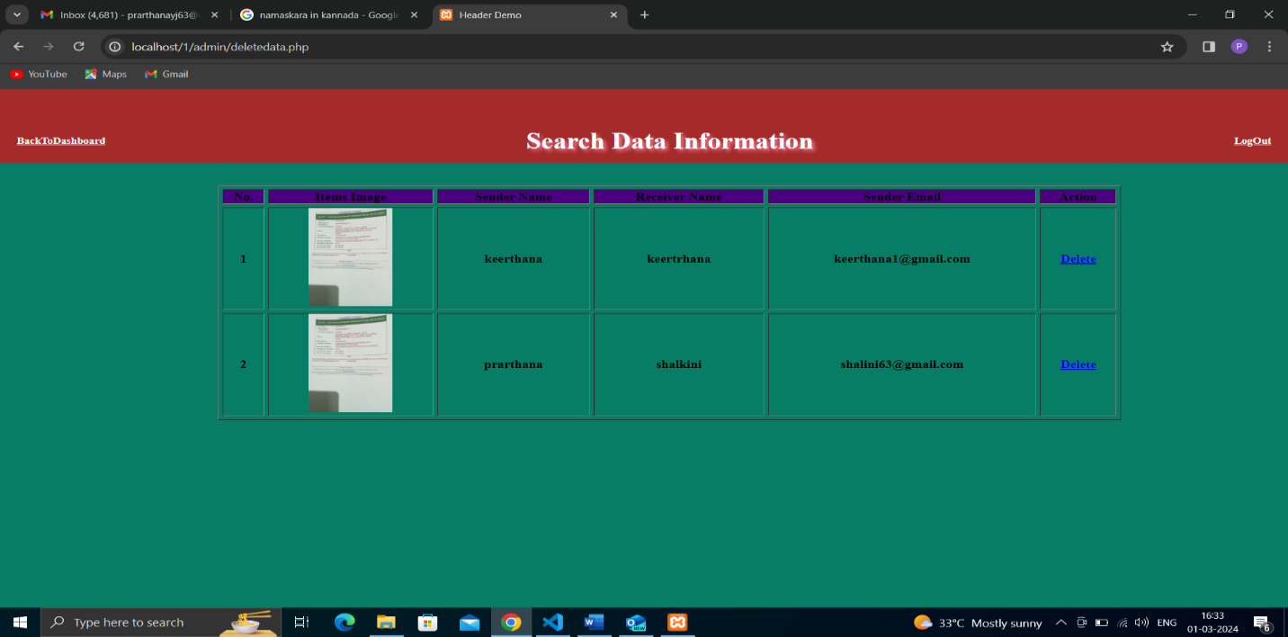

Fig 6.5:Track consignment page

**6.6 TRACK STATUS OF PARCEL**

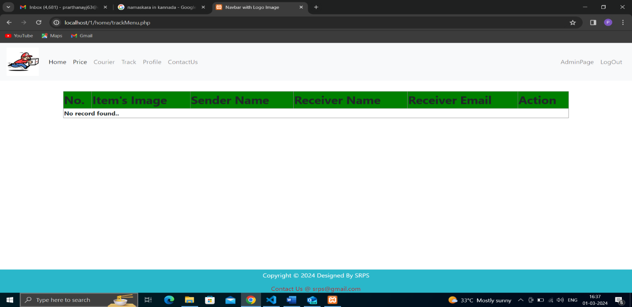

Fig 6.6: Track status of parcel

**6.7 PROFILE VIEW SECTION**

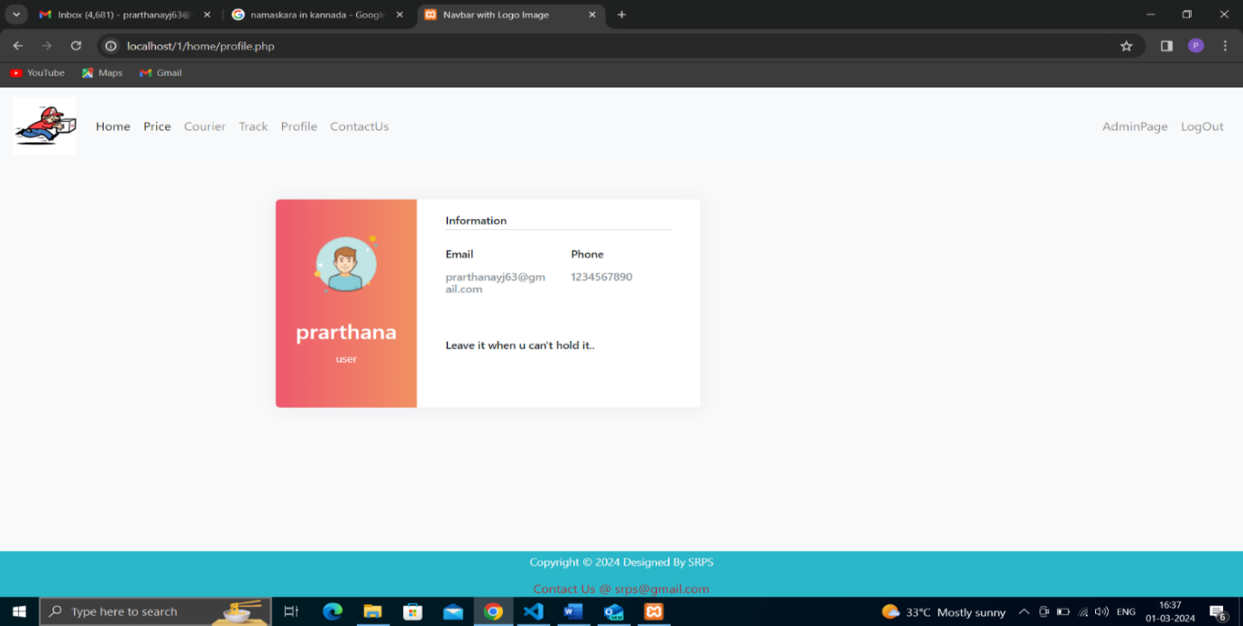

Fig 6.7: Profile view section

**6.8 CONTACT US SECTION**

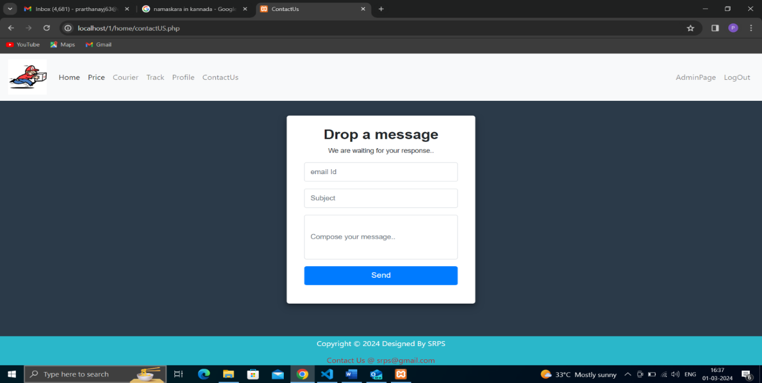

Fig 6.8: Contact us section

**6.9 REGISTER NEW USERS PAGE**

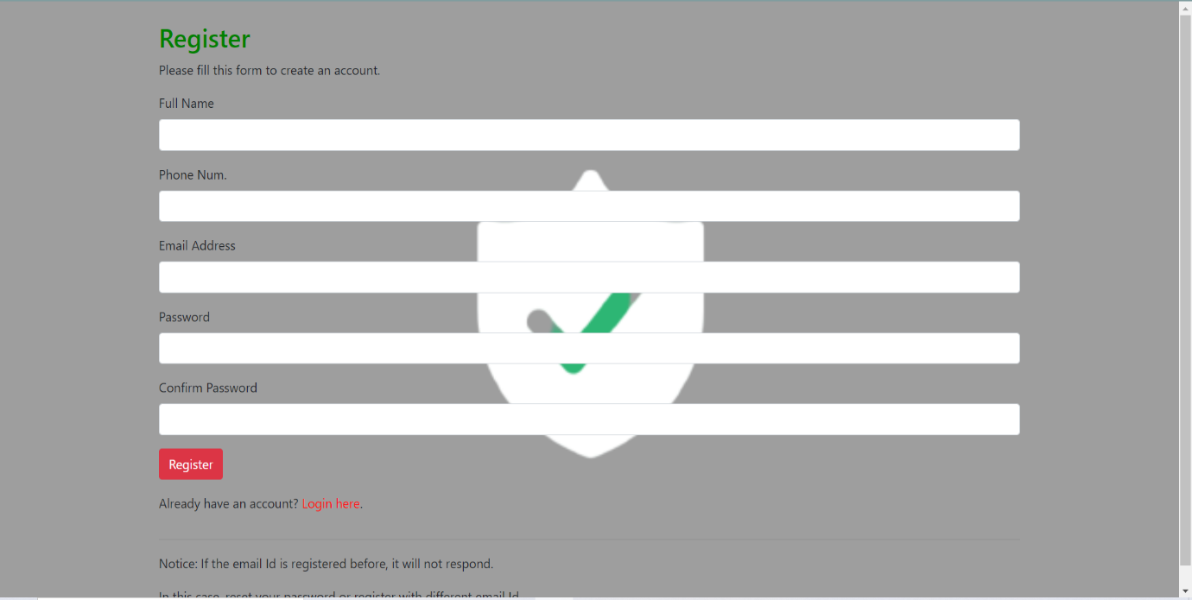

Fig 6.9: Register new users page

**6.10 ADMIN LOGIN PAGE**

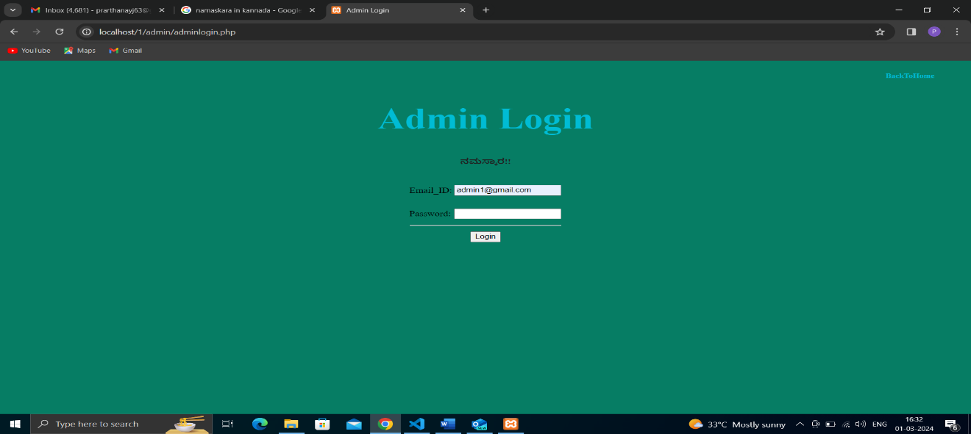

Fig 6.10: Admin login page

**6.11 ADMIN PAGE**

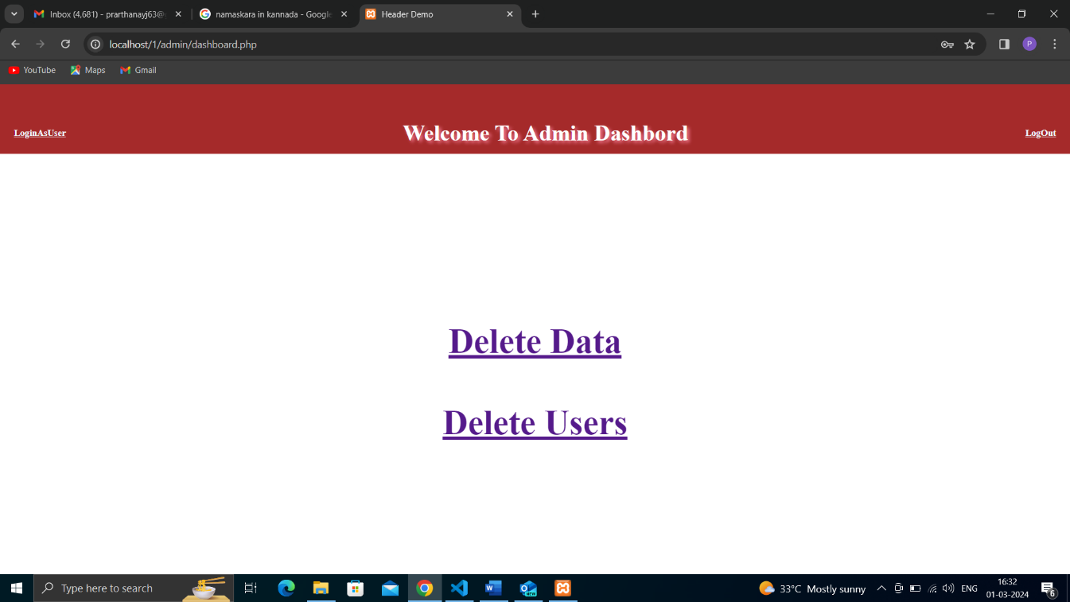

Fig 6.11: Admin page

**CONCLUSION**

System development is also considered as a process backed by engineering approach. We have tried to incorporate & develop new particles for our education particles have been followed not during the but coding but also during the analysis, design phases & in documentation.

Courier agency is considered as an expansion of business relations. It contributes a lot by

providing quick & fast services of sending documents letters (formal & informal both) to

business as it enables any business to flourish

Following modification or upgrades can be done in system.

1) More than one company can be integrated through this software.

2) Web services can be used to know exact delivery status of packets.

3) Client can check the repacked delivery status online.

4) Distributed database approach in place of centralized approach

**References and Bibliography:**

• http://www.bluedart.com/

• http://www.xamppserver.com/en/

• http://www.php.net/

http://youtube.com/

• http://www.tutorialspoint.com/mysql/

https//apache.org/docs/2.0/misc/tutorials.html